**BOGOTÁ CONSOLIDA**

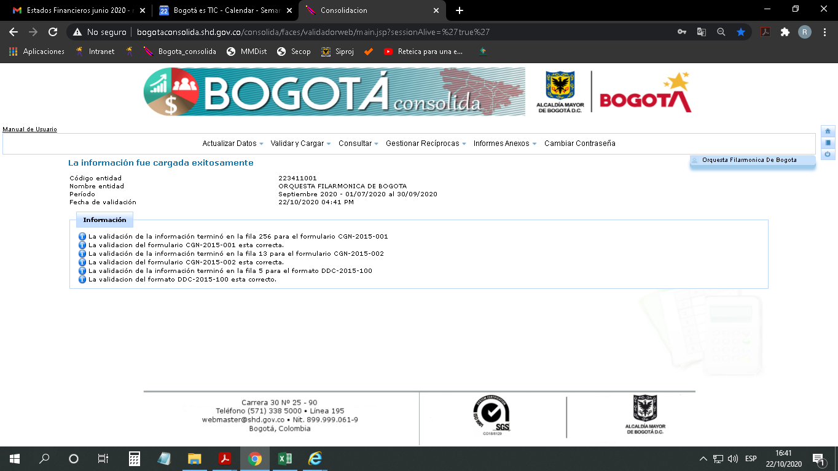

**CHIP LOCAL**

